**Internship Question**

1. **Create a form with validation. After that, submit the form and then print it.**
2. **Create Drop-down search bar in (react js with design)**
3. **Reference by (https://baratepriyanka.github.io/addvideo/video_2024-04-20_21-21-04.mp4) (react js with design)**
4. **Character counter for text areas where the first letter will be capitalized, followed by the entire sentence copied and pasted in uppercase, followed by the sentence in lowercase, and all extra spaces removed. Reference by (react js with design)**
5. 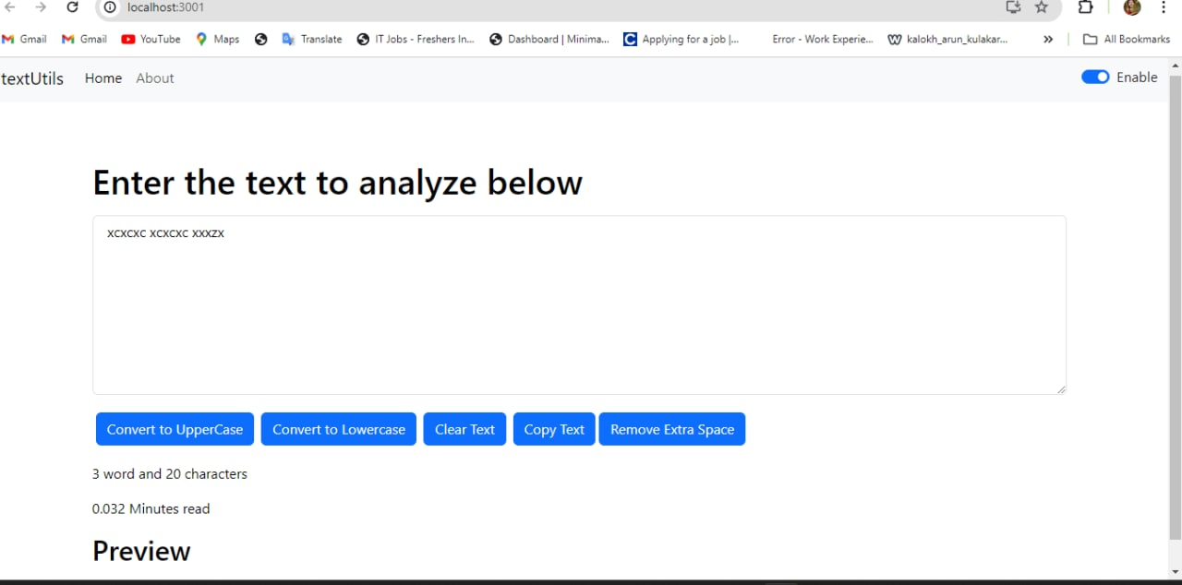
6. **Create the Spin Wheel in react js (react js with design)**
7. **Create Age calculator using html css and react js.**
8. **Celsius to Fahrenheit converter Reference by (https://baratepriyanka.github.io/addvideo/video_2024-04-20_22-18-24.mp4)**
9. **Create the Calculate app in react js.**
10. **Generate the captcha in react js Reference by (https://baratepriyanka.github.io/addvideo/video_2024-04-20_22-24-22.mp4)**
11. **Create Tic Tac Toe simple game In react js**
12. **Create any Url Shortner. r user can easliy long link is converted into short link or url. In reactjs Reference by (https://quicklink-a1wf.onrender.com/)**